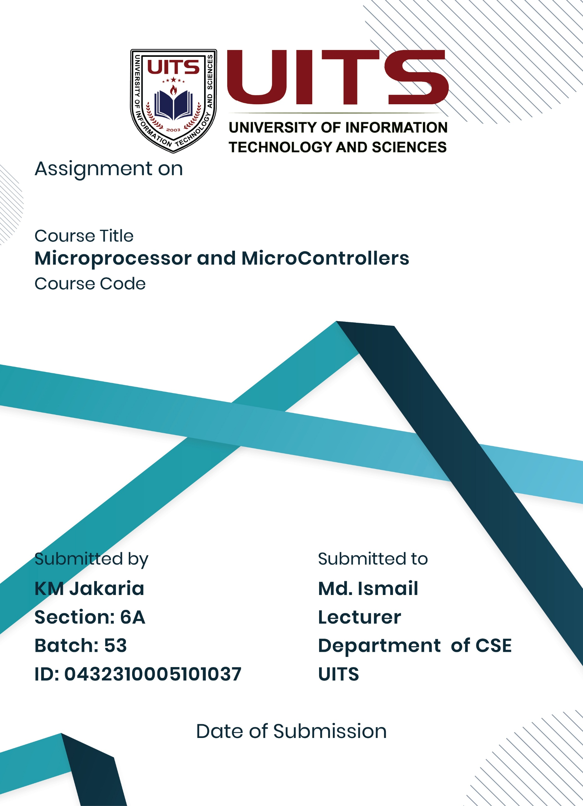
27 Aug, 2025
Lab Report- 01
CSE 360
Problem No: 01
Experiment No: 01
Experiment Name: Taking input from the user and printing as output on the same line.
Process:
Interrupt service procedure AH = 01H is used for user input; it receives a character from standard input and echoes it to standard output. The AL register contains the input character. After then, this value is transferred to BL for short-term storage. The character in the DL register is written to standard output using an interrupt service function with AH = 02H.

Implementation:
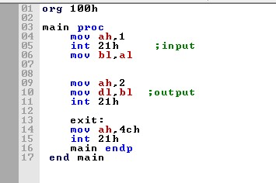

Result:
When the user enters "6", the program shows "6" once more, creating the visual "6 6" (the second '6" is from our output, and the first '6' is from the input echo). When the user enters "6", the program shows "6" once more, creating the visual "6 6" (the second '6" is from our output, and the first '6' is from the input echo).
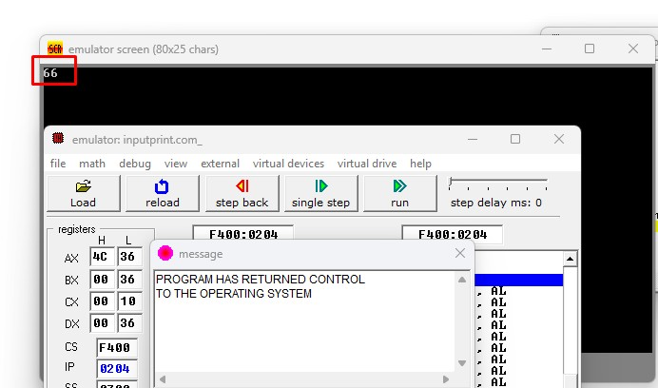

Conclusion:
The application effectively illustrates 8086 assembly language input and output processes. A simple way for character input and output is provided by the INT 21H interrupt with the proper function codes in the AH register. We see the input character twice—once from the explicit output instruction and once from the automatic echo—because when function 01H is used for input, the character is automatically echoed to the output. Our comprehension of fundamental I/O operations in 8086 assembly programming is validated by this experiment.

Problem No: 02
Experiment No: 02
Experiment Name: Taking input from user and printing as an output at the same line with tab
Process:
Interrupt service procedure AH = 01H is used for user input; it receives a character from standard input and echoes it to standard output. The AL register contains the input character. After then, this value is transferred to BL for short-term storage. Display the input character stored in BL after first displaying a tab character (ASCII 9) using an interrupt service function with AH = 02H.

Implementation:
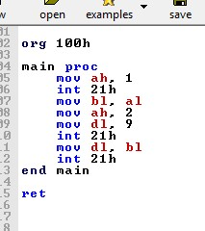

Result:
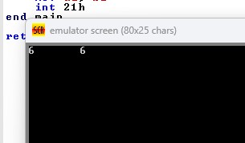
When '6' is entered by the user, the application shows a tab and then '6', which makes "6" appear on the screen (where the space is a tab character). The second '6' following the tab comes from our explicit output instruction, while the first '6' comes from the input echo.

Conclusion:
In 8086 assembly code, the program effectively illustrates input and output processes with formatting. We can produce output that is correctly structured by adding a tab character between the automatically repeated input and our explicit output. This experiment strengthens the fundamental I/O operations we previously learnt by confirming our comprehension of how to format output in assembly language programming using ASCII control characters (such as tab).

Problem No: 03
Experiment No: 03
Experiment Name: Input and Output Operations with Space Formatting in 8086 Assembly
Process:
Interrupt service procedure AH = 01H is used for user input; it receives a character from standard input and echoes it to standard output. The AL register contains the input character. After then, this value is transferred to BL for short-term storage. In order to display the input character stored in BL, first use an interrupt service procedure with AH = 02H to display a space character (ASCII 32).

Implementation:
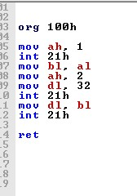

Result:
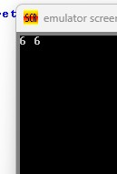
Inputting '6' causes the application to display a space after '6', which makes the screen read "6 6". Our explicit output command is responsible for the second '6' that follows the space, whereas the first '6' comes from the input echo. Inputting '6' causes the application to display a space after '6', which makes the screen read "6 6". Our explicit output command is responsible for the second '6' that follows the space, whereas the first '6' comes from the input echo.

Conclusion:
In 8086 assembly code, the program effectively illustrates input and output procedures with space formatting. We can produce output that is correctly formatted and clearly separated by adding a space character between the automatically echoed input and our explicit output. Building on the fundamental I/O operations we previously studied, this experiment validates our comprehension of how to format output in assembly language programming using ASCII characters. In contrast to the tab character, which might vary in width based on console settings, the space character offers a more straightforward and reliable separation.
Problem No: 04
Experiment No: 04
Experiment Name: Taking input from user and printing as a output at the new line
Process:
Interrupt service procedure AH = 01H is used for user input; it receives a character from standard input and echoes it to standard output. The AL register contains the input character. After then, this value is transferred to BL for short-term storage. For output, display the input character stored in BL after first displaying a carriage return (ASCII 13) and line feed (ASCII 10) using an interrupt service routine with AH = 02H to go to a new line.

Implementation:

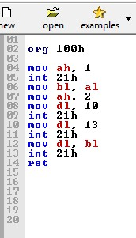
Result:
1. Shows '6' from the input echo on the first line when the user enters it
2. Goes to a different line
3. Returns to '6' from our explicit output command on the second line.
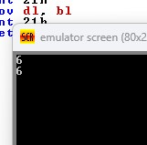

Conclusion:
In 8086 assembly code, the program effectively illustrates input and output procedures using new line formatting. We can construct output on a new line by adding carriage return (ASCII 13) and line feed (ASCII 10) characters between the automatically repeated input and our explicit output. This exercise demonstrates that we understand how to employ ASCII control characters for multi-line output and other sophisticated formatting in assembly language programming. For new lines to function properly in DOS settings, carriage return and line feed must be combined.

